Christian Assembly Newsletter April 2019
圣餐

当我们在主日聚会擘饼的时候，我们需要预备我们的心。我们要带着感恩的心来纪念主，感谢祂为我们所做的一切。当我们纪念主为我们所存的忍耐，愿我们心中和口中涌出敬拜。“我们应当靠着耶稣，常常以颂赞为祭献给神，这就是那承认主名之人嘴唇的果子。”（希伯来书13：15）多久一次服圣餐纪念主呢？正如保罗对特洛阿德信徒所说的：“七日的第一日，我们聚会擘饼的时候……”（使徒行传20：7）每周一次。
感谢主给了我们这个特权——我们可以聚集在一起纪念祂。很多人都没有这个特权。 我们纪念复活的主——被钉（在十字架上），复活，升天被高举在宝座上，直到祂再来。我们的祷告和赞美都应该以此为中心。当执事准备饼和杯的时候，会众应该静默思想（主的恩典和自己的罪）。
主耶稣的话：
在主耶稣被卖的那一夜，祂拿起饼，祝谢了，说：“这是我的身体，为你们舍的，你们应当如此行，为的是纪念我。”（哥林多前书11：24）“饭后，也照样拿起杯来，说：‘这杯是用我的血所立的新约，你们每逢喝的时候，要如此行，为的是记念我。”（哥林多前书11：25）我们每次吃这饼喝这杯的时候，都是在纪念主的死，直到祂再来。耶稣用逾越节的晚餐来表明祂道成肉身的救赎目的： 祂来是为了医治和救赎破碎的人类。 祂离开高天的荣耀，祂的家，来到受咒诅之地，作我们罪孽的赎价。当我们吃这饼喝这杯（这是祂受苦难的记号）的时候，我们是在承认祂是主，祂拥有绝对的主权。
省察自己：
所以无论何人，不按理吃主的饼，喝主的杯，就是干犯主的身、主的血了。所以我们应当自己省察，然后吃这饼、喝这杯（哥林多前书11：27-28）。我们要承认我们的罪：因为“神是信实的，是公义的，必要赦免我们的罪，洗净我们一切的不义。”（约翰一书1：9）“吃喝，若不分辨是主的身体，就是吃喝自己的罪了。（哥林多前书1：29）。
生命的代价：
我们记念主耶稣，祂救赎我们脱离律法的咒诅，和一切的罪孽——这是神照圣经所说，为我们的罪所献的赎罪祭。 我们每天都应当记念这伟大的救赎之工，尤其是在主日，在擘饼的时候.。我们想记念祂和祂因爱我们所经历的一切。“因基督也曾一次为罪受苦，就是义的代替不义的，为要引我们到神面前。按着肉体说，他被治死；按着灵性说，他复活了。”（彼得前书3：18）。
“耶稣对我的爱，在可咒诅的木头上受苦，我的舌头不能说尽”
那无罪的为我们的罪献上了生命得代价。 今天我们可以记得祂说：“我曾死过，现在又活了，直到永永远远”（启示录1：18）。“祂按自己的旨意，用真道生了我们，叫我们在他所造的万物中好像初熟的果子。”（雅各书1：18）因着恩典的缘故，祂为我们尝了死味。愿我们俯伏敬拜他，赞美祂，称谢祂，因祂是我们的救主，因祂为我们所做的一切。我主耶稣是何等奇妙的救主!
耶稣舍了祂的身体流出祂的宝血，使我们能够与祂和好，使我们得以完全。
总结：
Lifted up was He to die,
“It is finished” was His cry; Now in heaven, exalted high,
Hallelujah! What a Saviour. Our risen and reigning Lord God Almighty. Glorious Saviour, Glorious Lord!

作者：谢水莲姊妹



Beholding Him in increasing measure

Exodus 33:11a (NASB)
Thus the Lord used to speak to Moses face to face, just as a man speaks to his friend… I just started work in Houston, and this past week I had the opportunity to dine with a people who normally work remotely in other cities. Though I had interacted with them before, there was something added to our relationship that phone or email could not replicate. I felt like I finally was starting to know these colleagues.
Every meeting and meal was substantially different, because they were very different people. Some were more willing to share their lives, while others were more reserved. However, for all of them, one thing was true. As I saw their faces more and more each day (even just over 1 week), there was an increasing two-way openness between us. Exodus 33:23 (NASB)
“Then I will take My hand away and you shall see My back, but My face shall not be seen.”
God answered Moses’ prayer as far as possible. He allowed all of His goodness to pass before Moses (v19), and covered Moses with His hand (v22) to allow Moses to see His back in full glory. Through it all, Moses became the man closest to God in his generation.
Dear brothers and sisters, it is amazing that God desires to reveal His glory to us, and it’s even more amazing that He has provided ALL in His Son Jesus Christ! Let us take hold of this blessing of knowing Him in increasing measure, and even of beholding Him face-to-face.
For now we see in a mirror dimly, but then face to face. -1 Corinthians 13:12a (NASB)
-Contributed by Bro. Lemuel Soh


Notes and News

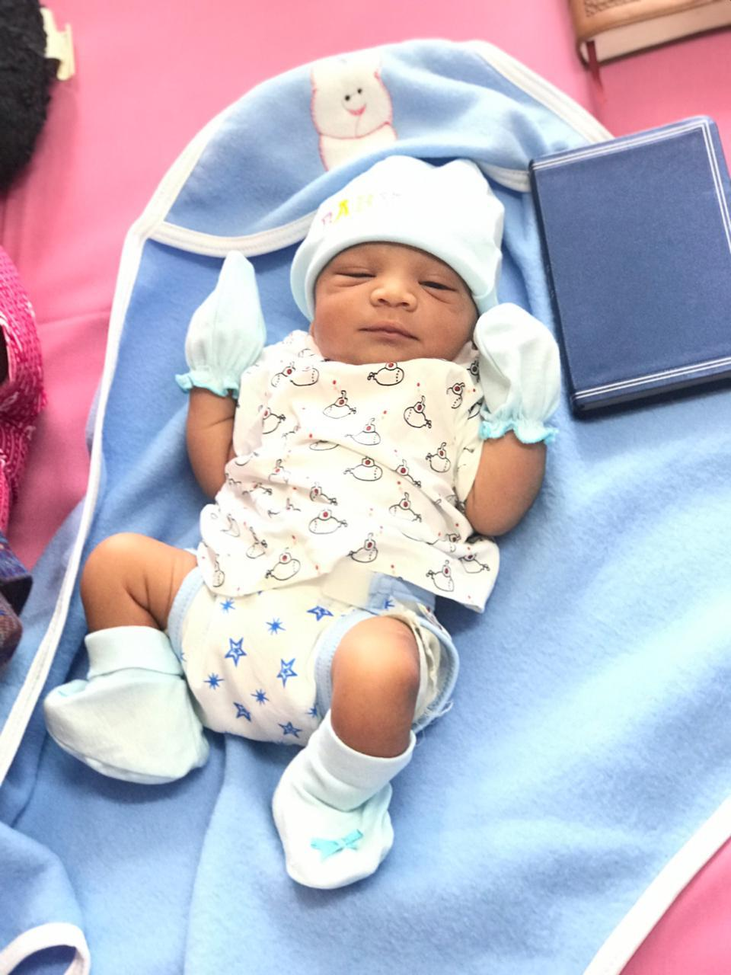
Bundle of joy
We thank and praise God for the birth of Joshua Daniel Rai, son of Bro. Anil and Sis. Rachel! Refer to their sharing below.

“Dear All,
We thank you for the persistent prayers offered for a healthy, safe confinement.
We are blessed with baby boy on the 5th March, 2019.
By the grace of God, he was dedicated in the house of God on the 6th day and was named Joshua Daniel Rai by the God servant at Hebron Church, Bangalore, India.
Yours in His eternal bonds,
Anil & Rachel”

Cambodia Mission Trip
We thank God for the safe journey of all the Cambodia Missioners (total 7 brothers & sisters) and God’s provision of the clothes they brought over. Many children as well as adults have indicated their interest to accept the Lord as Savior - Do continue to pray for the Holy Spirit’s on-going work in their lives as well as the growth of seeds that have been sown. The economy in Cambodia is also very bad so please pray for God’s provision & protection for His children.


Be careful for nothing; but in everything by prayer and supplication with thanksgiving let your requests be made known unto God. (Philippians 4:6)
And the peace of God, which passeth all understanding, shall keep your hearts and minds through Christ Jesus. (Philippians 4:7)

Prayer items
Watch and Pray

Pulpit ministry
May we all come before the Lord with a heart of reverence. Do remember our speakers and translators in prayer.
Our speakers are as follows:
Date | Speakers
Date | Wilkie | Asiawide | Gospel
07 Apr 2019 | Ling In Kee | Stephen Li | Billy Yeo
14 Apr 2019 | Yeo Choon Guan | Teo Ching Han
21 Apr 2019 | Chua Meng Khiang | Chng Yak Beng
28 Apr 2019 | Tan Boon Guan | Chua Meng Khiang

Baptism Service - 21July 2019
Pray for the upcoming baptism service that God will convict those who have yet to take the step of obedience to be willing to undergo the waters of baptism.

Gospel Meeting
Gospel meeting held monthly on the 1st Sunday at 5pm in Wilkie - it is a spiritual warfare so do keep in prayer all who are involved:
- Speakers & translators
- Pianists
- Those who give out gospel tracts
- Members who invite family & friends
- Involvement of young and old to support this work of the “great commission”

Youth Camp 19-20th April 2019
Pray that the youths will gain new insights of God and develop a deeper relationship with Him during the 2 days.

Those working with the youth

Pray for wisdom and discernment for those working with/guiding the youths in their walk with the Lord and how to unite the assembly as one body in Christ in activities, ministries and worship.

Elders and deacons
May the meetings be Christ-centered and discussions be on matters that God is concerned with.

Church Camp – 10 to 14 June 2019 (Batam)
Theme: “A man after God’s heart” (Acts 13:22)
Closing date of application: 14 April 2019
Items to submit: Completed form, transport fees and passport copy.

We have church camps year in year out, let us not take such camps for granted. Pray for hearts to hunger & wait in anticipation of God’s Word for the coming church camp.

Remember brothers and sisters who are not well, elderly and those who are not able to attend church:

- Bro Bobby Sng who has a weak heart
- Mr Leong & his wife Irene
- Bro Sng Hock Heng
- Bro Loh
- Sis Wong Hee Aik who is still in a coma. May the Lord’s will & purpose be done.
- Sis Sharon Chang
- Sis Wang Wei
- Bro. Liu Yi Quan who has swollen leg and intermittent fever. He has returned to China for treatment.
- Sis Lee Seok Hua
- Sis Goh Leng Kum
- Sis Teo Siew Eng
- Sis Christina Tan
- Others whom the Lord knows by name

May they experience God’s Presence during this time of pain & take comfort in His love & grace.

Church ministries
Your prayer support and involvement in any of the ministries would be an encouragement to the body of Christ.
From him the whole body, joined and held together by every supporting ligament, grows and builds itself up in love, as each part does its work.
-Ephesians 4:16


Newsletter … sharing of testimonies, pictures and articles to edify brothers and sisters

Transportation needs … Pray for brothers and sisters to volunteer to serve as Gospel van drivers and for those with cars to give lifts to those in needs especially the elderly and the younger ones living in various areas.
Note:
Please note that prayer requests are reported up to the 3rd Wednesday of every month in order to prepare for translation and preparation for the printing of the newsletter, which will target to be available on the 1st Sunday of every month.
Those prayer items requested on the 4th Wednesday of every month, which is valid only for the following month, will not be reported because by the time the next newsletter is printed, these prayer requests would have been outdated. We thank all church members for their understanding.

